| **Test Name** | | Update Worker details in Database | | | |
| --- | --- | --- | --- | --- | --- |
| **Use Case Tested:** | | Use Case 9 – Manage Worker | | | |
| **Test Description:** | | User needs to amend the details for a worker  User navigates to Search Workers tab  User is presented with a list of workers  User searches for the required worker  User amends the information  User submits form | | | |
| **Pre-conditions** | | Worker must exist in the system | | | |
| **Post-conditions** | | The database is successfully updated with the new data for the Worker. | | | |
| **Notes:** | | **If user tries to change the id of an existing worker, a message should appear.** | | | |
| **Result (Pass/Fail/Warning/Incomplete)** | |  | | | |
|  | **TEST STEP** | | **EXPECTED TEST RESULTS** | P | F |
|  | User selects “Search Workers” from the menu bar | | A list of workers appears | X |  |
|  | User searches for the required worker | | A list of workers matching criteria appears | X |  |
|  | User selects required worker | | Worker details is uploaded into the Worker Details form | X |  |
|  | User amends details as necessary | | Input does not show error | X |  |
|  | User selects Submit button | | Message appears that the record was successfully updated | X |  |
|  |  | | Database updated to show new details for worker | X |  |
|  | User selects “Search Workers” from the menu bar | | A list of workers appears | X |  |
|  | User searches for the required worker (same as test 1) | | A list of workers matching criteria appears | X |  |
|  | User selects required worker (same as test 1) | | Worker details is uploaded into the Worker Details form | X |  |
|  | User amends ID details | | Input does not show error | X |  |
|  | User selects Submit button | | Message appears indicating worker ID can’t be changed |  | X |
|  |  | | Database updated to show new details for worker | X |  |

|  |  |  |  |  |  |
| --- | --- | --- | --- | --- | --- |
| **Test Data Table** | | | | | |
|  | **1** | **2** | **3** | **4** | **5** |
| Test – 1 (current) | 6789 | Mary | Jones | Trainee | True |
| Test – 1 (amended to) | 6789 | Mary-Ann | Jacob | Trainee Pharmacist | False |
| Test – 2 (amended ID) | 6798 | Mary-Ann | Jacob | Trainee Pharmacist | False |
|  |  |  |  |  |  |

**Test 1**

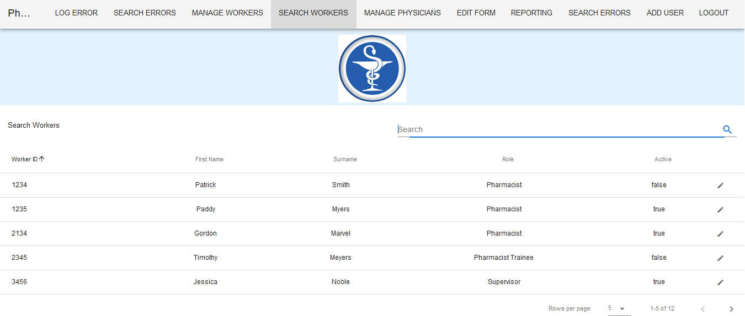

List of workers appears on selection of Search Workers tab.

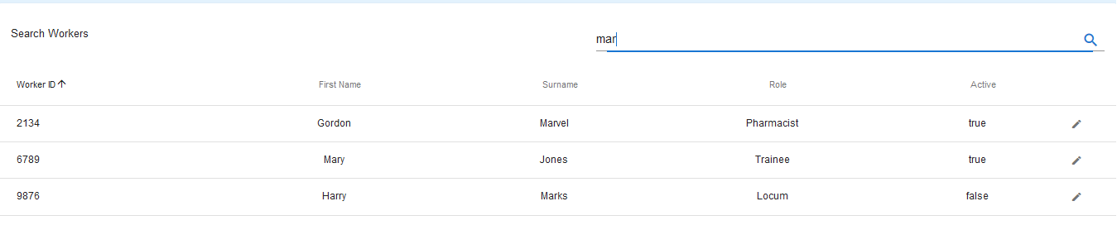

Search criteria returns three records.

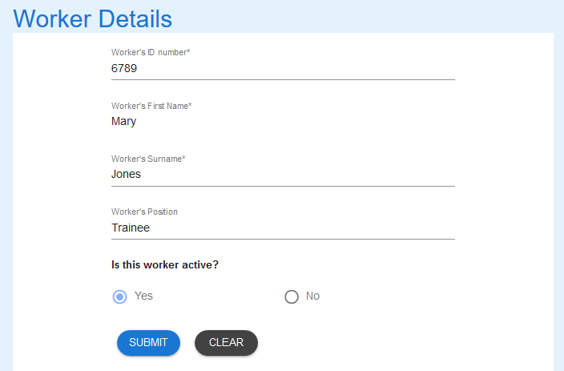

The record appears in the Workers Detail form

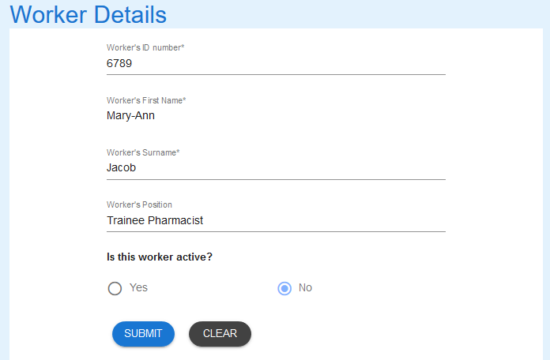

Updated details



Message returned

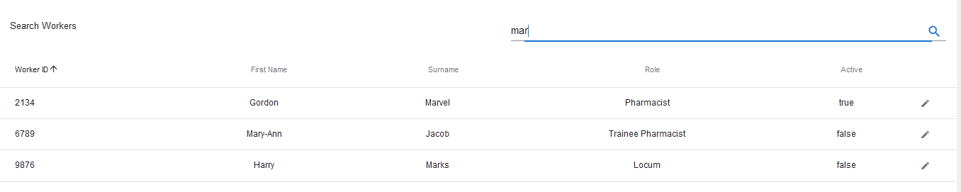

Record updated.

**Test 2**

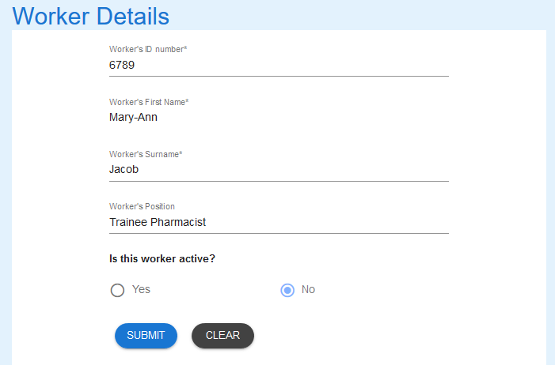

Worker is loaded into Worker Details upon selection.

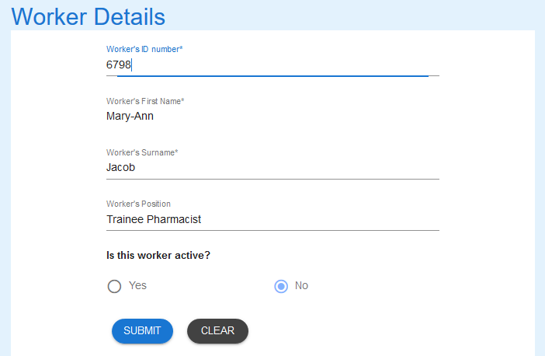

Worker ID has been changed.



Incorrect message appears. - FAIL

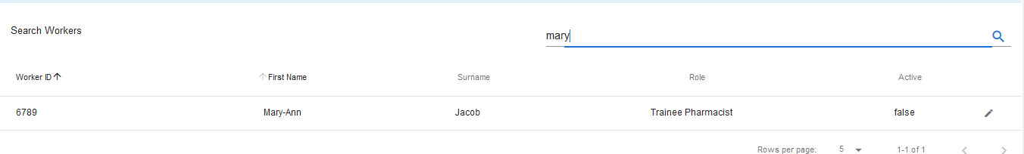

Record not updated - Pass